Node List

**PK Add Ons > Math**   
**Vector Lerp over Time**Transition from one vector to another. Several Smoothing choices.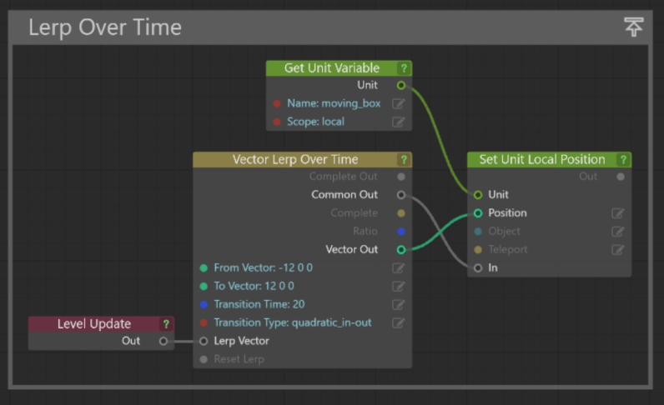  
*Inputs*  
From Vector – Starting point/vector  
To Vector – Ending point/vector.  
Transition Time – How long (in seconds) the transition should take  
Transition Type – Easing functions.  
Lerp Vector – Lerps from the From Vector to the To Vector  
Reset Lerp – Resets the Lerp  
  
*Outputs*  
Complete Out – Pulses when complete.  
Common Out – Fires Every Frame  
Complete – Signals “True” when complete, “False” if not.  
Ratio – Gives an output from 0 to 1 based on its percentage of completion.  
Vector Out – The current Position in the Lerp.

**PK Add Ons > VR**  
**Laser Pointer**  
Creates a highly customizable laser pointer   
(supply your own mesh(s) for laser/contact or leave blank to use the default ones supplied)  
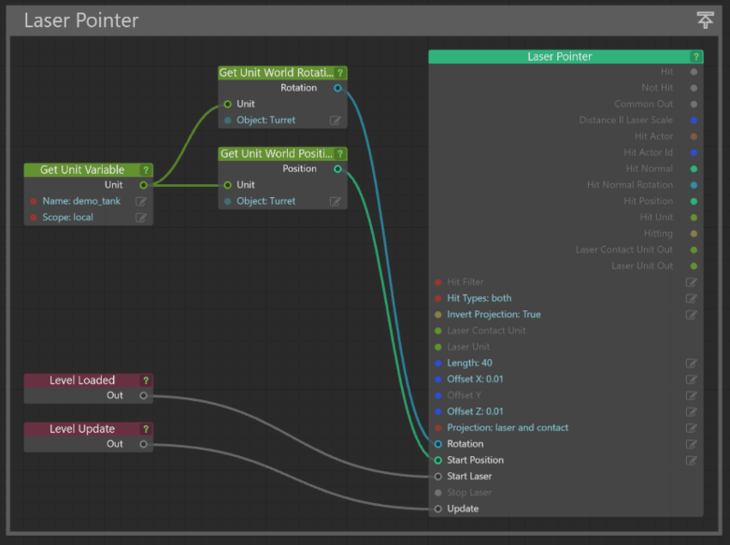  
  
*Inputs*  
Hit Filter – Enter the fit filter you want to use.  
Hit Types – Selects the hit types (Dynamics, Statics, or Both) you want the laser to interact with.  
Invert Projection – Flips the laser.  
Laser Contact Unit – (Optional) Lets you supply a custom Laser Contact Unit.  
Laser Unit – (Optional) Lets you supply a custom Laser Unit.  
Length – The maximum distance the laser will test for a contacted unit.  
Offset (X,Y,Z) – Lets you offset the laser starting point.  
Projection – Defines the projection type. Laser Only, Contact Only, Laser and Contact.  
Rotation – The direction you want to fire the laser pointer.  
Start Position – The position the laser pointer starts from.  
Start Laser – Pulse once to start the laser.  
Stop Laser – Pulse once to Stop the laser.  
Level Update – Activates/Runs the laser.

*Outputs*  
Hit – Pulses once when it hits a new collision object.  
Not Hit – Pulses once when it is no longer hitting a collision object.  
Common Out – Pulses every frame.  
Distance/Laser Scale – Gives the distance/laser length.  
Hit Actor – Gives the actor being hit by the laser  
Hit Actor ID – Gives the actor id of the actor being hit.  
Hit Normal – Gives the Normal Vector of the hit position.  
Hit Normal Rotation – Gives the Rotation of the hit Position.  
Hit Position – Gives the location in world space of the position hit by the laser.  
Hit Unit – Gives the unit hit by the laser.  
Hitting – Replies with true/fasle for whether the laser is currently hitting a physics actor.  
Laser Contact Unit Out – Gives access to the laser Unit.  
Laser Contact Unit – Gives access to the laser contact unit.

**PK Add Ons > Lights  
Light Flicker**Flickers a light unit  
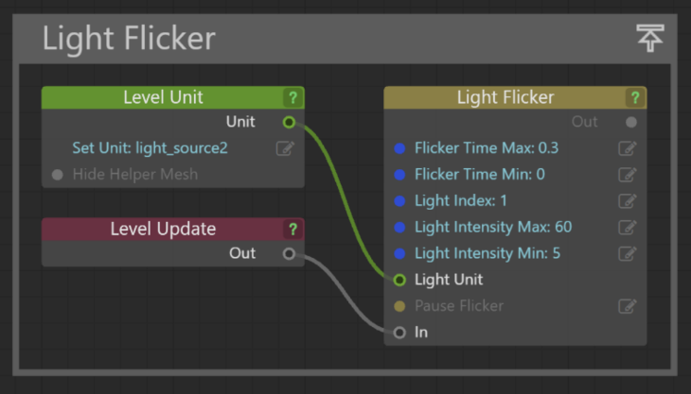  
  
*Inputs*  
Flicker Time Max – The maximum amount of time in seconds a light will remain in a flicker state for.  
Flicker Time Min – The minimum amount of time in seconds a light will remain in a flicker state for.  
Light Index – Usually 1. This is the node of the light source.  
Light Intensity Max – The maximum brightness a flicker state can be.  
Light Intensity Min - The minimum brightness a flicker state can be.  
Light Unit – The light unit you want to affect.  
Pause Flicker – Pauses the flicker.  
In – Update every frame to flicker the light.  
 *Outputs*  
Out – Pulses each time any of the input events are fired.

**PK Add Ons > Materials  
Color to Percent**   
Lets you input a standard RGB (255, 255, 255) value and outputs a stingray appropriate color.  
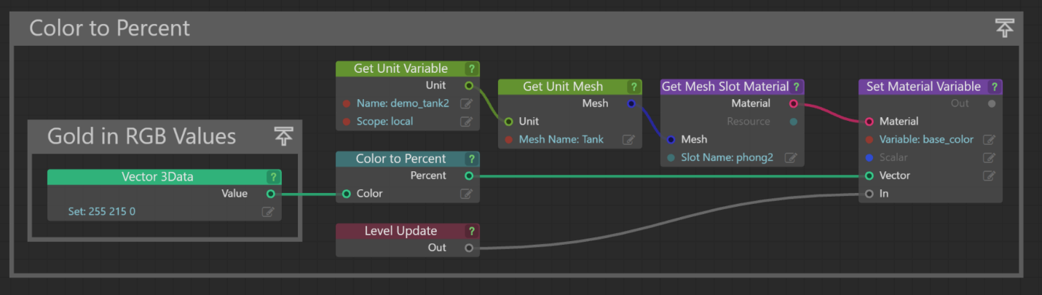  
  
*Inputs*  
Color – A vector containing the standard RGB values. 0-255.  
  
*Outputs*  
Percent – A vector containing the RGB values as a percent. 0-1

**PK Add Ons > Cursor  
Enable/Disable Cursor**   
Toggles the cursor on and off.  
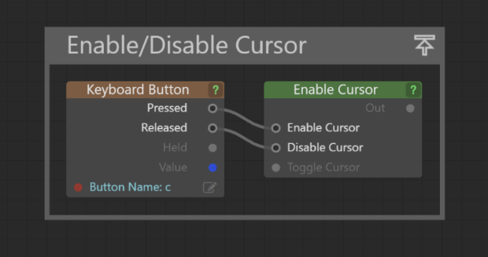  
*Inputs*  
Enable Cursor – Pulse once to activate the cursor  
Disable Cursor – Pulse once to disable the cursor  
Toggle Cursor – Pulse once to swap the toggle the state of the cursor on/off.  
Outputs  
Out – Pulses each time any of the input events are fired.

**Super Debugger**  
Debugs any data type, prints to screen or console, lets you even set a prefix/suffix message.  
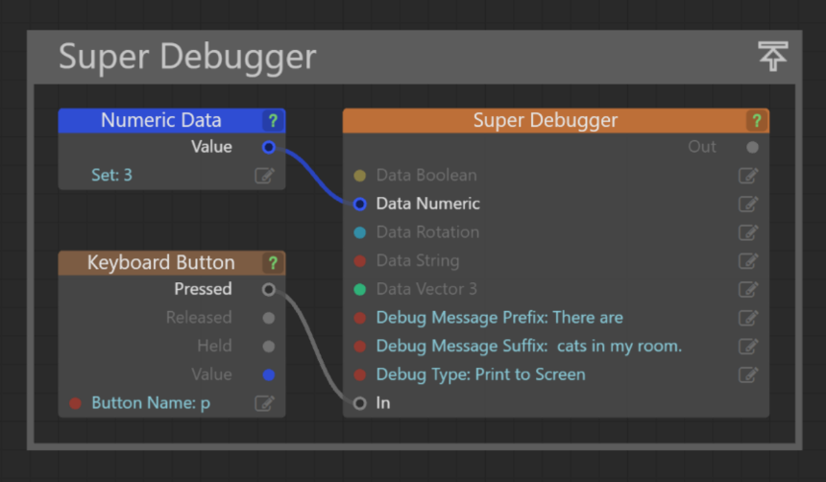  
  
Inputs  
 n

**System Time** - Output your computers time in string or numeric format. Calculates the Meridiam, offers both 12h and 24h format.

**Super Sum** - Add a bunch of numbers together.

**Look at Unit** - Have one unit/mesh look at another unit. Allows for smoothed start for extra goodness.

**Super Concatenator** - Concatenates a bunch of strings together, allows you to use a custom concatenator plus prefix/suffix strings.

**Gaze Teleport** - Gaze in a direction, icon counts down, you teleport to the location. No interaction required.

**NTh Update** - Updates every Nth Update. Great for sending messages to the console so you dont flood it.

**Replace Material** - Swap Materials the easy way!

**Replace and Remember Material** - Swaps materials but remembers its original material. Use reset to return the material to its original. Use reset all to return any meshes youve swapped materials on to their original state.

**Single Sequence** - Run down a sequence with each consecutive click. Allows for looping, notifies when the sequence is complete and more. Great for switching cameras in a sequence, or well anything you need to do with sequential inputs from the user.